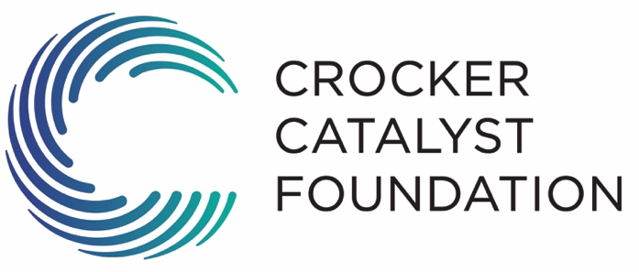

Send completed applications to:
Crocker Catalyst Foundation
Att: Lisa Meiling
6900 S. 900 E. Suite 230, Midvale, UT 84047

Or Lisa@sdihq.com

Please submit applications by one of the following deadlines: January 1st, April 1st , June 1st or September 1st. Applicants will be notified by email of the decision.

Include the following with your application:

- A list of the Board of Directors and Officers
- A project budget for the specific project for which funding is being requested
- A copy of the organization’s 501(c)(3) determination letter from the IRS (Unnecessary for cities, public schools, or other municipalities)
- The most recent audited financial statement and annual operating budget which clearly delineates the percent of budget used for fund raising and administrative costs
- Any pamphlets/brochures or other information descriptive of the organization (optional)
- If a restoration or construction project is intended, please provide photographs or architect’s rendering
- Letters of support
- Other documents that may help us understand your project or organization better. (optional)

Applicant Information:

Name of Organization:

Name listed on 501-(c)(3):

Address:

Phone: ___ Fax:

Primary Contact Person: Title:

Phone: e-mail:

Secondary Contact Person: Title:

Phone: ____ e-mail:

CCF Board Contact (optional) : ________________________________

URL Address: _____________________________________Founding Date _____

Description and mission of organization:

Name of proposed project:

Amount requested:

Total cost of the proposed project:

Description of the project/program for which funding is being requested:

If awarded the full request, describe how the funds would be used:

Description of the target population and number of people served by this project:

Project timetable (start and end date):

Number of volunteers your project will utilize:

Number of paid staff employed by your organization:

List key staff positions and salaries:

Position Salary

List each potential public and private major donor, including amount for this project:
Name Amount

List each committed major donor, including amount received or pledged, for this project:
Name Amount

Describe the proposed method of evaluating the program’s effectiveness and past performance (if applicable):

Have you ever received support from the Crocker Catalyst Foundation, if so, please list the three most current periods of funding.

Year Amount

Have you been evaluated by Charity Navigator or similar organization? (i.e. Better Business Bureau, National Charities Information Bureau, etc.)

Do you meet all standards?

Organizational Classification:
Age Group Served
Ethnicity
Gender
Geographical Area
Organization Type
Population Served
Annual Operating Budget:

Annual Operating Budget Summary:
Previous year Current Year
(Actual) (Projected)
Revenues
Public support
Zoo Arts & Park Tax
United Way
Federal
State (Trust Lands)
City
County
Other

Total public support ____________

Private support
Foundations
Individuals
Corporations
Fundraisers
Other

Total private support ______

Earned Income (i.e. ticket
Revenue, Interest, fees, etc.)

Total Revenues

Expenses
Fundraising & Administrative
Salaries and benefits
Building, rent & Maintenance
Advertising
Supplies
Disbursements for tax-exempt
Purpose
Other

Total Expenses _______

